# Installation guide for *LCLCIM* (Windows 10)

*LCLCIM* is a browser application for visualization of Comprehensive Three-Dimensional LC × LC × Ion Mobility Spectrometry Separation Combined with High-Resolution Mass Spectrometry (LC×LC×IM‑MS) data. See Venter et al. 2018[1] for background information. Three-dimensional Total Ion Chromatograms (TIC), Extracted Ion Chromatograms (EIC) or Single Ion Chromatograms (SIC) of the LC×LC×IM-MS data are visualized in 3D scatter plot. The size of each data point and its color in the 3D scatter plot indicates the intensity value. The entire high resolution mass spectra for a certain data point is obtained in a separate bar plot by clicking on a data point in the 3D scatter plot of the TIC.

Input files must be in .mzML format and have to be converted into a Pandas data frame which is saved in a Python .pickle file using the build in converter in the app. Note that the conversion process depends on the size of the .mzML file and can therefore take a long time. The .pickle file is saved to disk and can be loaded into the app for visualization at any time.

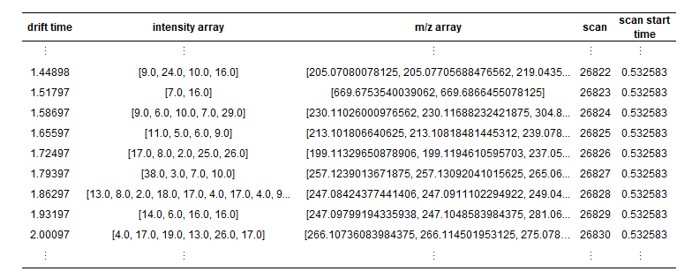

Figure 1: Structure of the Pandas Dataframe saved as .pickled

## Install Anaconda/Miniconda

The browser application *LCLCIM* is written in Python 3 and runs in a Conda environment. To use the one-click-installation of *LCLCIM* you have to have miniconda or anaconda installed on your PC. The Anaconda Distribution is a free, easy-to-install package manager, environment manager and Python distribution with a collection of 1,000+ open source packages with free community support. Miniconda is a lightweight version of anaconda.

Simply follow the installation description on the anaconda website (unless you have Anaconda already running on your PC):

Anaconda: <https://docs.anaconda.com/anaconda/install/windows/>

Miniconda: <https://docs.conda.io/en/latest/miniconda.html>

Anaconda vs. Miniconda: <https://docs.conda.io/projects/conda/en/latest/user-guide/install/download.html#anaconda-or-miniconda>

## Install *LCLCIM*

Download all *LCLCIM* related files from GitHub **(REPO HERE… and link).** Create a new folder for *LCLCIM* and copy all relevant data into it. Execute the install.bat file (double click). And wait until the installation of all packages is completed. Now, *LCLCIM* is ready to run.

## Start *LCLCIM*

Start *LCLCIM* by simply executing the run.bat file (double click). A new browser window opens. If no browser window opens automatically, simply add the following address <http://localhost:8080/> into a manually opened browser window.

If you want you can create a desktop short cut for the run.bat file.

1. Venter, P.; Muller, M.; Vestner, J.; Stander, M. A.; Tredoux, A. G. J.; Pasch, H.; de Villiers, A. Anal. Chem. 2018, 90 (19), 11643– 11650, DOI: 10.1021/acs.analchem.8b03234